Collect the Crop! – SDG 2 ‘Zero Hunger’
For my continuous assessment in Computing and Culture I was required to create a game to promote one of the seventeen sustainable development goals. The goal I chose was the second one, ‘Zero Hunger’. My plan is to create a game in Unity that promotes learning on this goal for upper primary level students in a way that might appeal to their demographic.

Core concept
My game will be in a similar vein to ‘Subway Surfers’ or ‘Temple Run’. These are vertical scroller games where the player can move left and right and collect various items while avoiding obstacles. In my rendition of this I will be creating a game where the player will play as a farmer and collect crops that have finished growing while avoiding spoiled crops and other obstacles. The players main goal will be to fill up a bar that represents progress to defeating world hunger. Once that bar is full, they win the game.

Target audience
The target audience is upper primary school students. The game will be more on the simplistic style to reflect this with easy-to-understand controls – swiping left and right to move for example.

Platforms
This game will be developed on Unity 2022.3LTS and it will be deployed on android mobile devices.

Intended impact
The intended impact of this would be to raise awareness of the importance of farming and growing of food and how sometimes crops fail shown by the spoiled crops in game.

Chosen SDG and Overview
The SDG I have chosen is the second SDG ‘Zero Hunger’. The Zero Hunger goal is to create a world free of hunger by 2030. Since 2015 the issue of hunger has grown at an alarming rate due to issues such as the pandemic, climate change, inequalities and global conflicts.

Game Concept
The genre of the game is runner, the player is playing as a farmer collecting their crops to be distributed to people. The player experience will be the game is played on a mobile device, and it will be controlled with touch controls. The players main goal will be to fill up a bar that represents progress to defeating world hunger. Once that bar is full, they win the game. The spoiled crops will subtract player progress from the bar and fresh crops will add to it.

Low Level Prototype
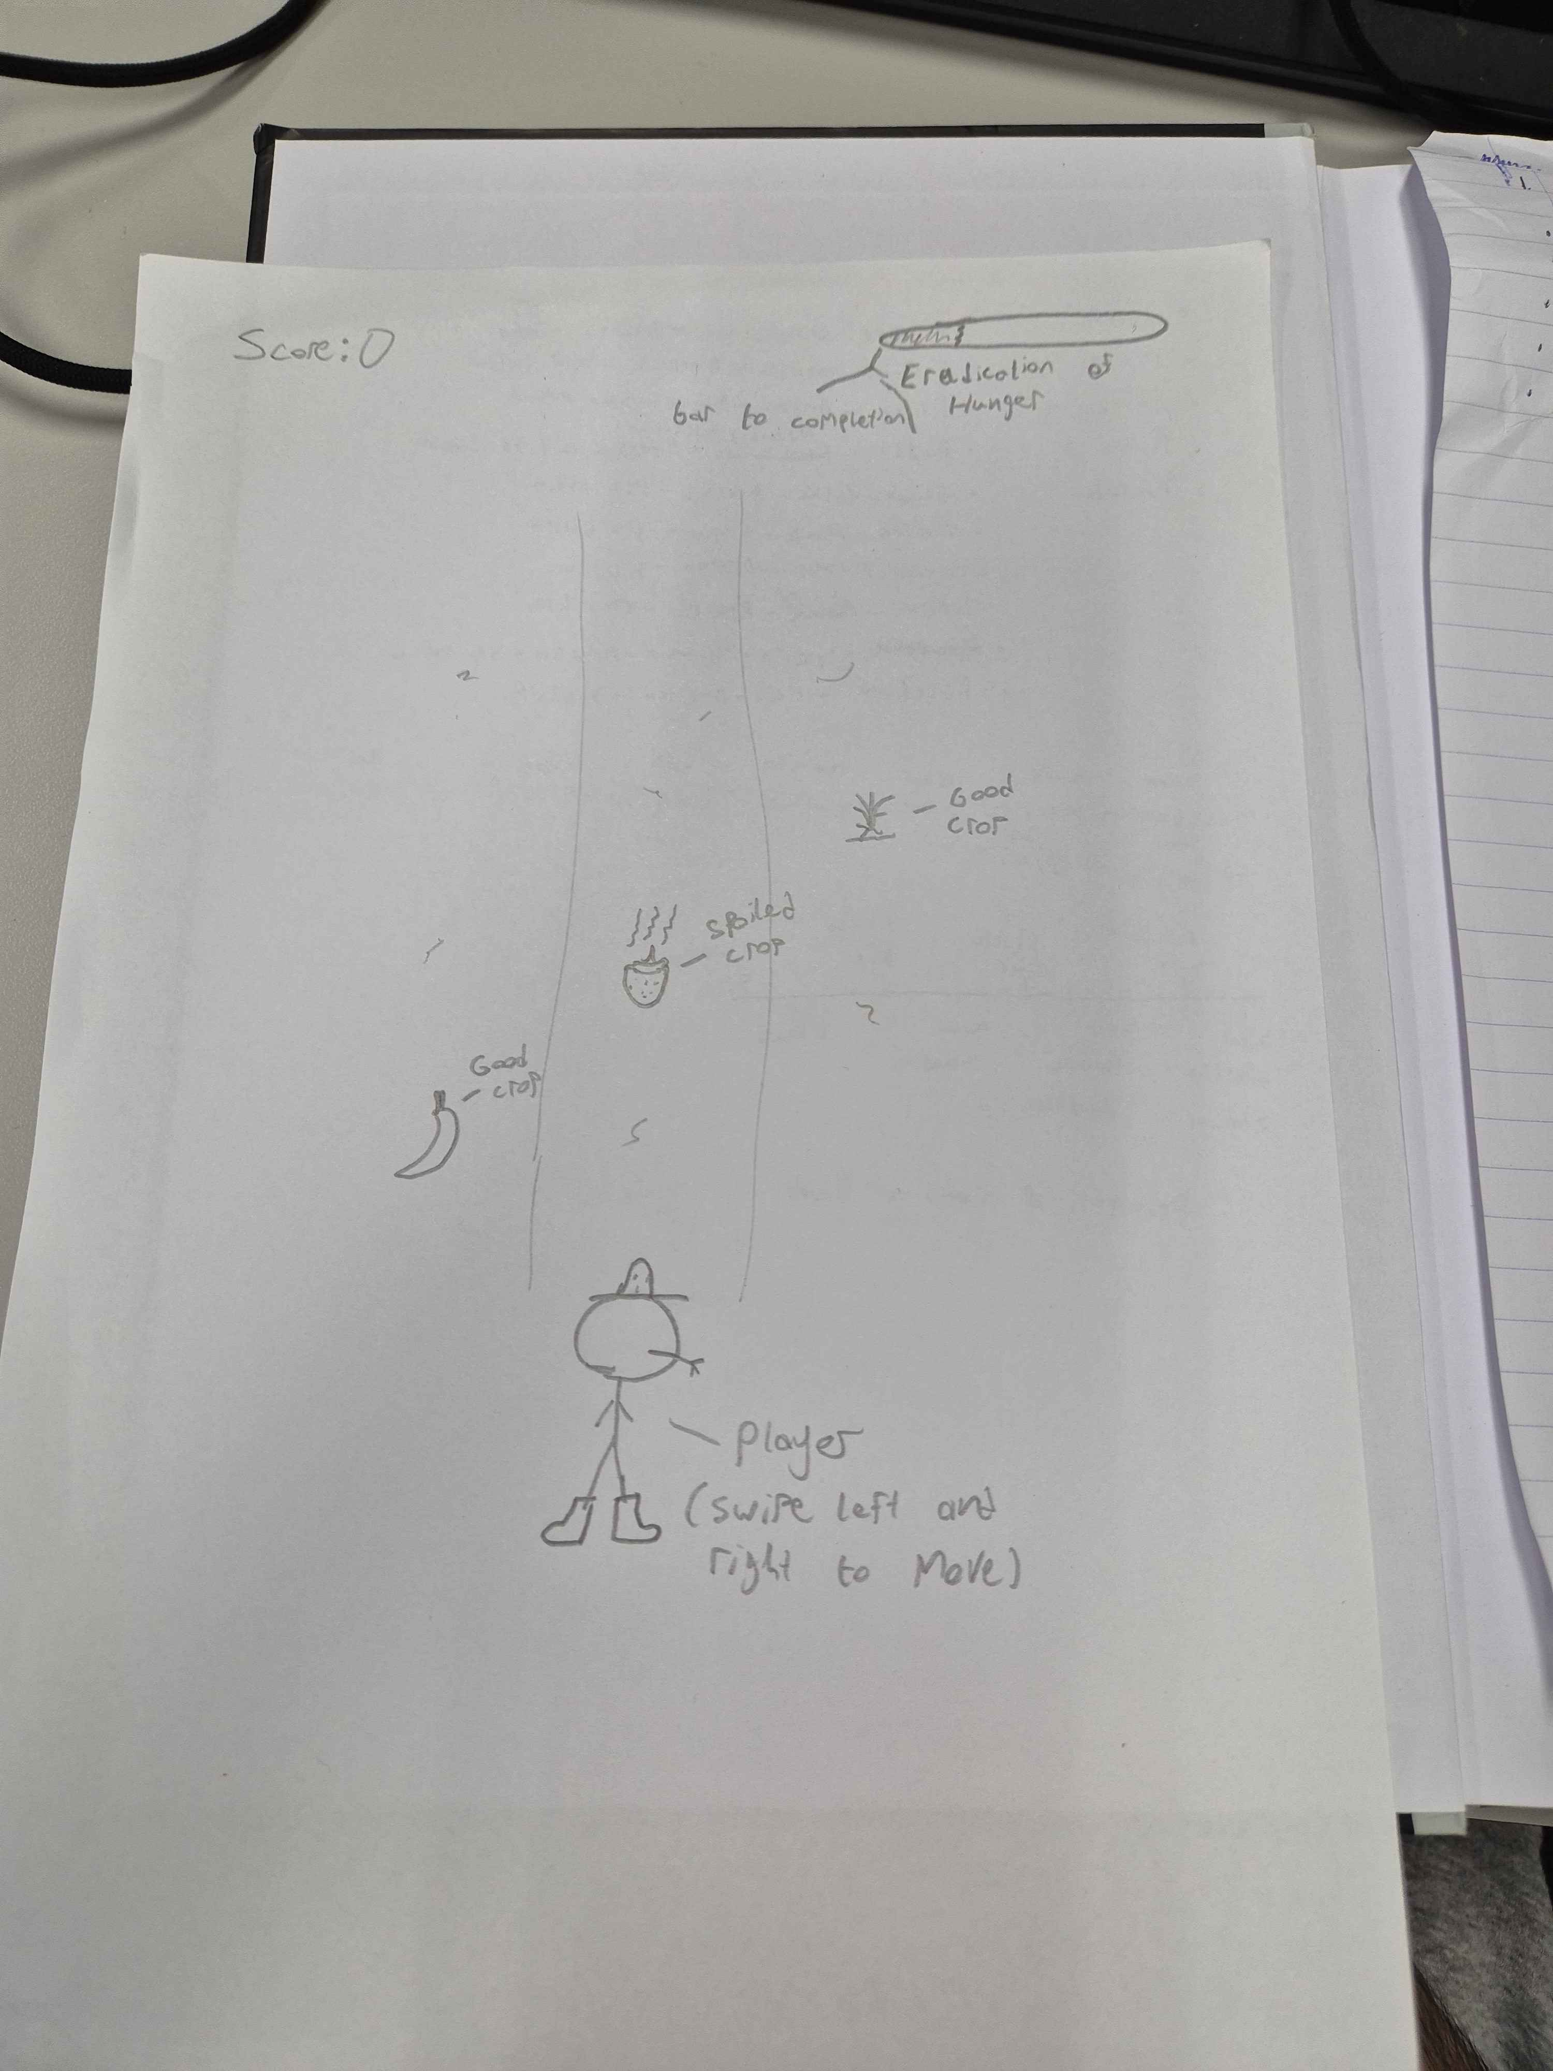
Figure 1 Low level prototype diagram
This diagram shows how I intend the game to work. The player swipes left and right to move in three lanes and there is a bar that the player must fill by collecting good crops and avoiding spoiled crops.
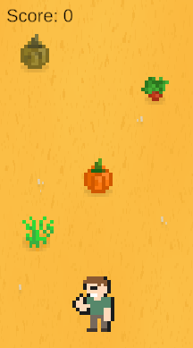
Figure 2 Low level Prototype on unity
This is a visual of how the game might look on completion in Unity.

